IBN7LIVE

HRD Minister Smriti Irani launches Kendriya Vidyalaya Sangthan's e-initiative 'KV Shaala Darpan'
Posted on: 05:40 PM IST Jun 05, 2015
PRESS TRUST OF INDIA
New Delhi: Union HRD Minister Smriti Irani on Friday launched Kendriya Vidyalaya Sangthan's (KVS) e-initiative 'KV Shaala Darpan', which will provide all information about students electronically on a single platform.
Terming it a "history", the Minister said the initiative was a step towards realising Prime Minister Narendra Modi's dream of Digital India. "The government has completed one year and this programme launched by KVS in its first year will define e-governance, good governance and Digital India and create a history. "PM has dedicated his dream project Digital India to the nation. This is an initiative towards realising that dream," she said.
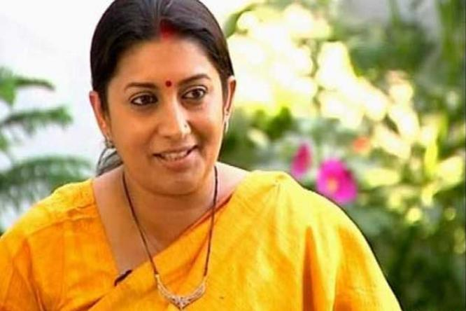
Observing that there was a negative mindset towards government schools, Irani said the government was working towards changing it and this initiative was in that direction.
#HRD #KV Shaala Darpan #KV's #smriti irani
Observing that there was a negative mindset towards government schools, Irani said the government was working towards changing it and this initiative was in that direction.
"It is heartening that government schools (KVs) are making this initiative which is historic. There is a presumption that government schools are not good enough and it is the endeavour of the government to bring them at par with private schools so that citizens would send their children to government schools feeling that it is not a compromising situation but an informed and very correct decision," she said.
"This on behalf of the government is an initiative to strengthen our governance," she said.

'Kendriya Vidyalaya Shaala Darpan': Smriti Irani launches e-initiative for Central Schools

Union Human Resource Development Minister Smriti Irani on Friday launched an initiative that will provide e-tutorials to students of Kendriya Vidyalayas while providing information about them on a single platform.
Comment
New Delhi: Union Human Resource Development Minister Smriti Irani on Friday launched an initiative that will provide e-tutorials to students of Kendriya Vidyalayas while providing information about them on a single platform.
The `Kendriya Vidyalaya Shaala Darpan` programme of Kendriya Vidyalaya Sangathan will write a new definition of e-governance, good governance, and digital India, Irani said on this occasion, adding it was a step in the direction of fulfilling Prime Minister Narendra Modi`s vision of digital India.
"Parents will get information about their children in respect to their attendance status, performance, health challenges and entire academic record from class 1 to12. Students will have facilities of e-tutorials to enrich their knowledge," Irani said.
The project will link all 1,100 Kendriya Vidyalayas, she added.
Earlier, Minister of State for Human Resource Development Upendra Kushwaha said the new programme will work in the direction of bringing transparency in administration and governance.

Smriti Irani Launched KVS E-Initiative ‘KV Shaala Darpan
Union Human Resource Development Minister Smriti Irani on Friday launched Kendriya Vidyalaya Sangthan’s (KVS) e-initiative ‘KV Shaala Darpan’, which will provide all information about students electronically on a single platform.
Terming it a “history”, the Minister said the initiative was a step towards realising Prime Minister Narendra Modi’s dream of Digital India. “The government has completed one year and this programme launched by KVS in its first year will define e-governance, good governance and Digital India and create a history. “PM has dedicated his dream project Digital India to the nation. This is an initiative towards realising that dream,” she said.
The `Kendriya Vidyalaya Shaala Darpan` programme of Kendriya Vidyalaya Sangathan will write a new definition of e-governance, good governance, and digital India, Irani said on this occasion, adding it was a step in the direction of fulfilling Prime Minister Narendra Modi`s vision of digital India.
“Parents will get information about their children in respect to their attendance status, performance, health challenges and entire academic record from class 1 to12. Students will have facilities of e-tutorials to enrich their knowledge,” Irani said.

Smriti Irani: KV Shaala Darpan programme will redefine e-governance

Union Human Resource Development Minister Smriti Irani, while launching KV Shaala Darpan programme of Kendriya Vidyalaya Sangathan here today, said the programme will write a new definition of e-governance, good governance, and digital India.
By: ANI | June 5, 2015 10:54 pm

Union Human Resource Development Minister Smriti Irani, while launching KV Shaala Darpan programme of Kendriya Vidyalaya Sangathan here today, said the programme will write a new definition of e-governance, good governance, and digital India.
Elaborating upon the details, Irani said this programme will be a step forward in the direction of fulfilling the vision of digital India of Prime Minister Narendra Modi.
She further said that with the launch of KV Shaala Darpan, parents would get entire information at a unified platform about their children in respect of the attendance status, performance, health challenges and entire academic record from Ist to XIIth standard.
Students will also have facilities of e-tutorials and learning aids to enrich their knowledge.
Irani made an appeal to the parents not to put unnecessary pressure on the children while availing the facility of getting instant information under this system.
First Published on June 6, 2015 8:57 am

KV Shaala Darpan programme will redefine e-governance: Smriti Irani
Jun 5, 9:11 pm

New Delhi, June 5 (ANI): Union Human Resource Development Minister Smriti Irani, while launching KV Shaala Darpan programme of Kendriya VidyalayaSangathan here today, said the programme will write a new definition of e-governance, good governance, and digital India.
Elaborating upon the details, Irani said this programme will be a step forward in the direction of fulfilling the vision of digital India of Prime Minister Narendra Modi.
She further said that with the launch of KV Shaala Darpan, parents would get entire information at a unified platform about their children in respect of the attendance status, performance, health challenges and entire academic record from Ist to XIIth standard.
Students will also have facilities of e-tutorials and learning aids to enrich their knowledge.
Irani made an appeal to the parents not to put unnecessary pressure on the children while availing the facility of getting instant information under this system. (ANI)

Smriti Irani unveils plan to help parents to monitor wards in KV schools

Saturday, 6 June 2015 - 7:20am IST | Place: New Delhi | Agency: dna | From the print edition

- 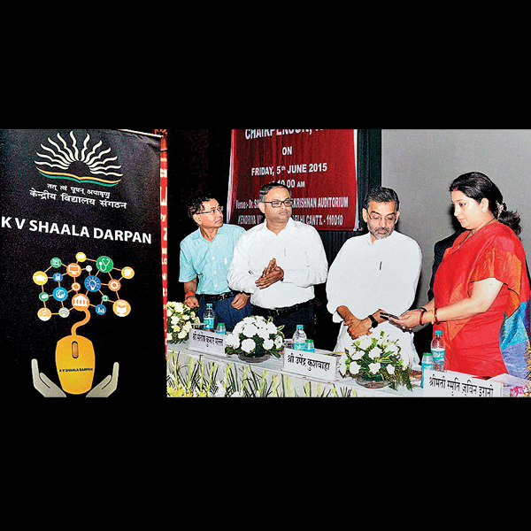
- HRD minister and chairperson, KVS, Smriti Irani launching the KV Shaala Darpan for Kendriya Vidyalayas, in New Delhi on Friday. Minister of State for Human Resource Development, Upendra Kushwaha is also seen PTI
Much against her usual arrogant and pretentious self, Human Resource Development Minister Smriti Irani on Friday for a change shed her stereotyped cast. She was all an image of humility and modesty, while talking to school children, their parents and teachers. The occasion was launching of e-governance programShala Darpan for the Kendriya Vidyalaya Sanghatan (KVS).
Shala Darpan is an online portal meant to maintain an online data base of each student. From attendance to examination papers, study material, medical conditions and health challenges, everything will be recorded in the software for any reference. The portal, developed by National Informatics Centre (NIC) will also provide a parent-teacher interface and also help parents to regularly monitor their wards. They will also receive routine progress reports of their wards, besides the conduct during school hours.
Using satire and at times emotions, reminding audience she was also mother of two children, she was at best to connect with the audience. Referring to the software Shala Darpan helping the parents to monitor their wards on real time basis, she said her own children were too happy not studying in the Kendriya Vidhyalaya. "I can understand how important it is for a parent to get timely first hand information about performance of the child. Parents of these students will not have to wait for the parent teachers meeting day," she added.
But the minister was quick enough to put a word of caution for the parents, asking them to remind their own childhood, "I know what it means when a teacher writes a note in the dairy. The child wants to hide it first from the mother and then from the father. If the note has to be signed by the parent, many here might have tried to copy the signatures of our parents," she added.
The minister advised parents to take feedback in the positive spirit. "Shala Darpan will provide you with routine updates, if you get to know that the child was not performing well, don't panic and don't pressurise your child. In fact it will give you time to work on your child at home," she explained.
Irani called the program a step in the direction of Prime Minister Narendra Modi's vision of e-governance, good governance and digital India plan. She also said that four states have expressed their interests in having a similar software for their schools.

KVS' E-move to Help Keep Tab on Wards
By Express News Service
Published: 06th June 2015 06:00 AM
Last Updated: 06th June 2015 06:00 AM
Email4
- 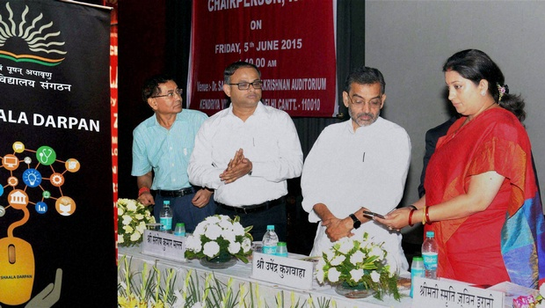
HRD minister Smriti Irani launching the ‘KV Shaala Darpan’, in New Delhi on Friday | PTI
NEW DELHI: Now parents would get online information on the performance of their children, including their attendance, from Class I to Class XII.
Human Resource Development Minister Smriti Irani launched ‘KV Shaala Darpan’, a Kendriya Vidyalaya Sangathan (KVS) initiative to provide attendance status, performance, health challenges and entire academic record of every student on a unified platform, here on Friday.
“Prime Minister Narendra Modi has dedicated his dream project ‘Digital India’ to the nation. This is an initiative towards realising that dream.
“The government has completed one year and this programme launched by the Kendriya Vidyalaya Sangathan in its first year will define e-governance, good governance and ‘Digital India’ and create history,” she said.
”It is heartening that government schools (KVs) are taking this initiative, which is historic. There is a presumption that government schools are not good enough and government’s endeavour is to bring them at par with private schools so that citizens would send their children to government schools feeling that it is not a compromising situation, but an informed and very correct decision,” Irani said.
Under the programme, students would get e-tutorials and learning aids to enrich their knowledge.
She appealed to the parents not to put unnecessary pressure on children while making use of the ‘KV Shaala Darpan’.
Posted at: Jun 5 2015 4:15PM

KV Shaala Darpan to script new definition of e-governance, Digital India: Smriti
New Delhi, Jun 5 (UNI) Union Human Resource Development Minister Smriti Irani today launched the KV Shaala Darpan programme of Kendriya Vidyalaya Sangathan here, saying that the programme would script "a new definition of e-governance, good governance, and digital India". Elaborating, the Minister said, "The programme would be a step forward in the direction of fulfilling the vision of digital India of our Prime Minister Narendra Modi.

CITIES » DELHI
NEW DELHI, June 6, 2015
Updated: June 6, 2015 05:33 IST

KVS launches e-governance project
- STAFF REPORTER
The Kendriya Vidyalaya Sangathan (KVS) created a history of sorts in the field of education and e-governance with the launch of the “KV Shaala Darpan” in a function organised at Delhi Cantonment here on Friday.
Speaking on the occasion, Union Human Resource Minister Smriti Zubin Irani congratulated KVS for being a pace-setter in the field of education apart from being a leader in promoting the Prime Minister’s vision of a Digital India.
The “KV Shaala Darpan” project will enhance a school’s academic delivery and serve as a platform to offer services to students, parents, teachers, alumni and school management. The system is expected to link 1,100 Kendriya Vidyalayas and will encompass all academic and administrative functions to help the Sangathan operate more effectively.

KV Shaala Darpan programme will redefine e-governance: Smriti Irani
Source :

Last Updated: Fri, Jun 05, 2015 21:45 hrs
Union Human Resource Development Minister Smriti Irani, while launching KV Shaala Darpan programme of Kendriya Vidyalaya Sangathan here today, said the programme will write a new definition of e-governance, good governance, and digital India.
Elaborating upon the details, Irani said this programme will be a step forward in the direction of fulfilling the vision of digital India of Prime Minister Narendra Modi.
She further said that with the launch of KV Shaala Darpan, parents would get entire information at a unified platform about their children in respect of the attendance status, performance, health challenges and entire academic record from Ist to XIIth standard.
Students will also have facilities of e-tutorials and learning aids to enrich their knowledge.
Irani made an appeal to the parents not to put unnecessary pressure on the children while availing the facility of getting instant information under this system. (ANI)

HRD Minister Smriti Irani launches KV Shaala Darpan programme of Kendriya Vidyalaya Sangathan

Friday, June 05, 2015 | Email Story Feedback Print Story

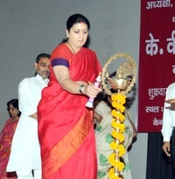
?
Report by India Education bureau, New Delhi:The Union Human Resource Development Minister Smt. Smriti Irani while launching KV Shaala Darpan programme of Kendriya Vidyalaya Sangathan in New Delhi today said that the programme will write a new definition of e-governance, good governance, and digital India.
Elaborating upon the details the Minister said that this programme will be a step forward in the direction of fulfilling the vision of digital India of our Prime Minister Shri Narendra Modi. She further said that with the launch of KV Shaala Darpan, parents will get entire information at a unified platform about their children in respect of the attendance status, performance, health challenges and entire academic record from Ist to XIIth standard. Students will have facilities of e-tutorials and learning aids to enrich their knowledge. She made an appeal to the parents not to put unnecessary pressure on the children while availing the facility of getting instant information under this system.
Earlier Minister of State for Human Resource Development, Shri Upendra Kushwaha said that KV Shaala Darpan programme will work in the direction of bringing transparency in administration and governance. This programme will ensure saving of money, time and paper. He further appealed to parents to devote maximum time to their children in the interest of their complete development.
A documentary film was also shown on the occasion with focus on the KV Shaala Darpan project and how it will enhance school’s overall academic delivery systems and serve as a platform to deliver service to students, parents, teachers, alumni and the school management. The project will link all 1100 Kendriya Vidyalayas.

The senior officers of Ministry of HRD as well as Kendriya Vidyalaya Sangathan were also present on the occasion.

Parents of Kendriya Vidyalaya students to get online info on performance
Fri, 05/06/2015 - 22:20--Edited By Gauri Shankar
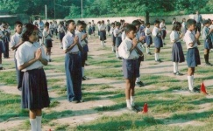

The HRD minister said that KV Shaala Darpan programme will be a step forward in the direction of fulfilling Prime Minister Narendra Modi's vision of digital India.

A programme which will provide parents online information about their wards performance in class including attendance was launched by HRD Minister Smriti Irani in Delhi, promising that it will write a new definition of e-governance and good governance.

She said that KV Shaala Darpan programme will be a step forward in the direction of fulfilling Prime Minister Narendra Modi's vision of digital India. The programme was launched by her at a Kendriya Vidyalaya here during which Irani said that complete information about students under this initiative will be available from Class I to XII.

Parents will get entire information at a unified platform about their children in respect of the attendance status, performance, health challenges and entire academic record, she said. "The government has completed one year and this programme launched by KVS in its first year will define e-governance, good governance and Digital India and create a history.

"PM has dedicated his dream project Digital India to the nation. This is an initiative towards realising that dream," she said. Observing that there was a negative mindset towards government schools, Irani said the government was working towards changing it and this initiative was in that direction.

"It is heartening that government schools (KVs) are making this initiative which is historic. There is a presumption that government schools are not good enough and it is the endeavour of the government to bring them at par with private schools so that citizens would send their children to government schools feeling that it is not a compromising situation but an informed and very correct decision," she said.

"This on behalf of the government is an initiative to strengthen our governance," she said. Under the programme students will have facilities of e-tutorials and learning aids to enrich their knowledge. She appealed to the parents not to put unnecessary pressure on the children while availing the facility of getting instant information
- See more at: http://liveindia.in/parents-kendriya-vidyalaya-students-get-online-info-performance#sthash.l9saNWMF.dpuf

