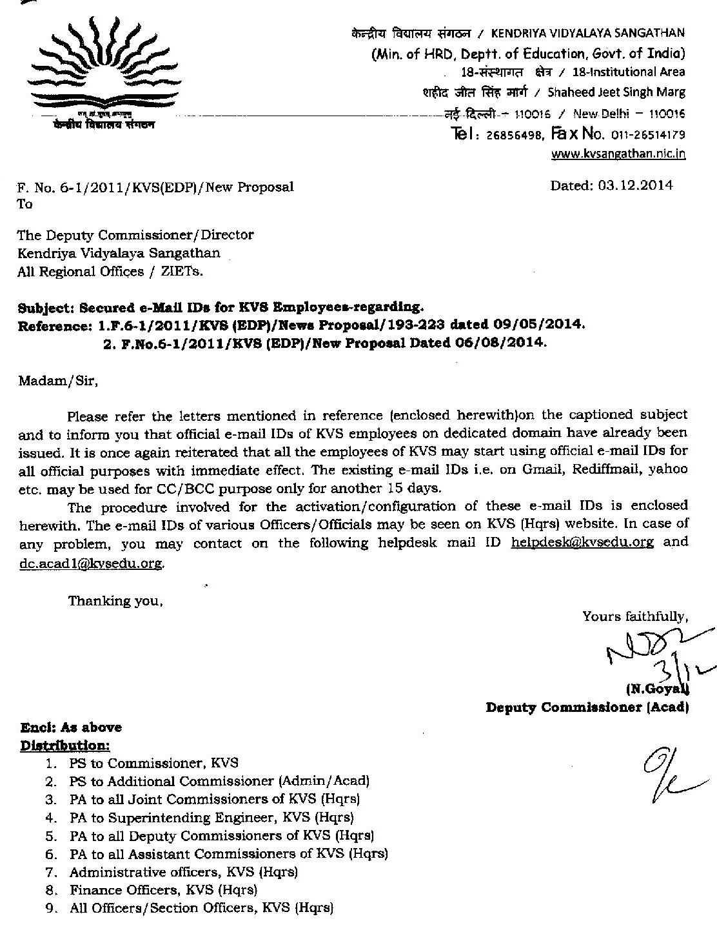

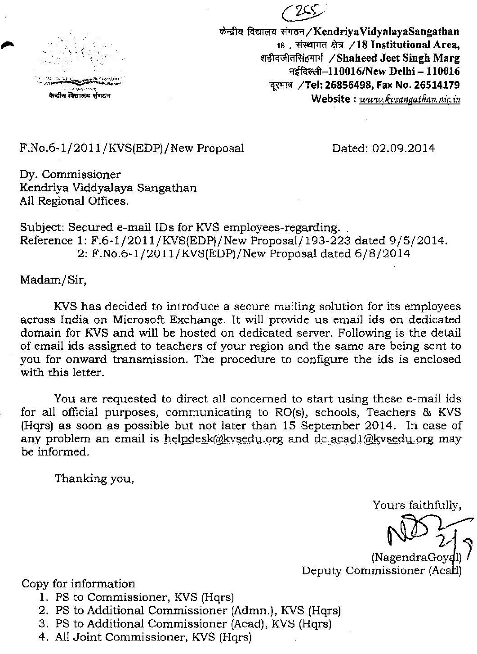

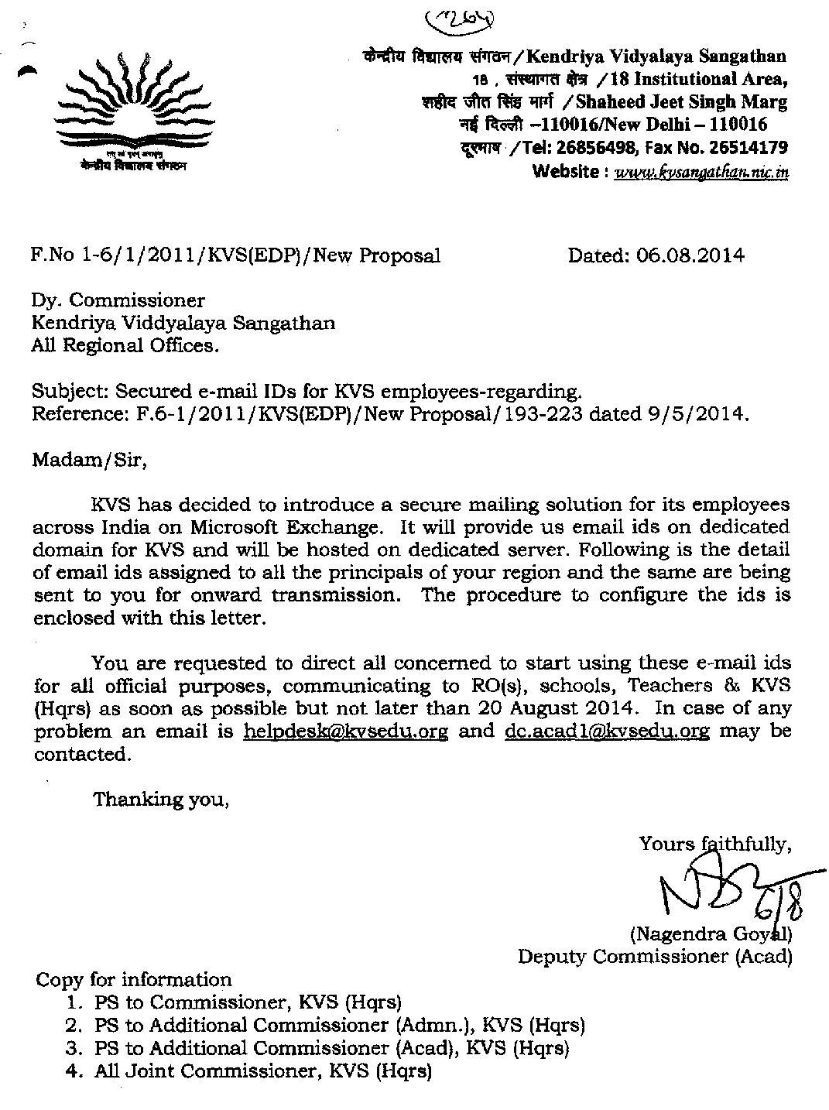
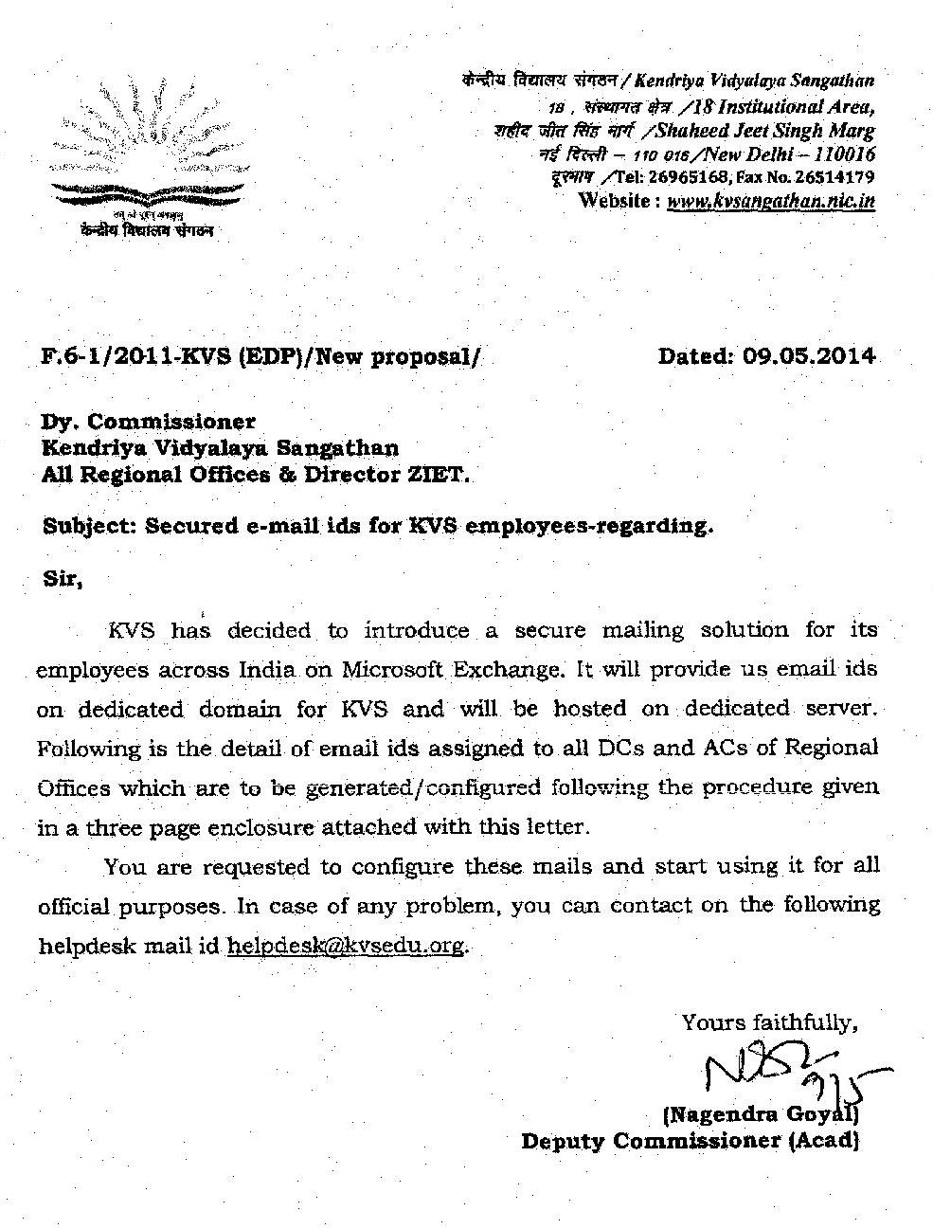
How to access KVS mail
- Open any browser viz. Internet explorer, Chrome, Netscape and open URL
https://mail.kvsedu.org
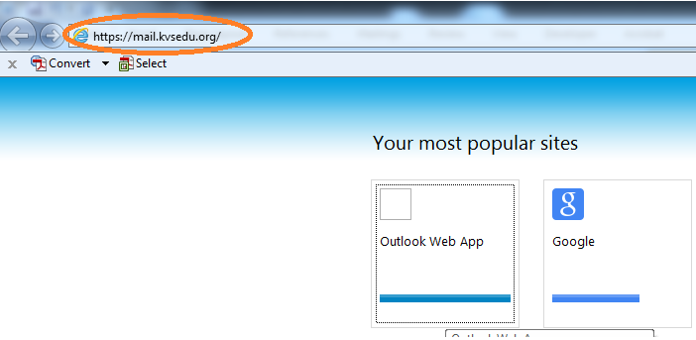
- Type your username in the next screen. If you email ID is XYZ@kvsedu.org then you username will be XYZ.

- Type kvs@123 in the password field and click Sign In
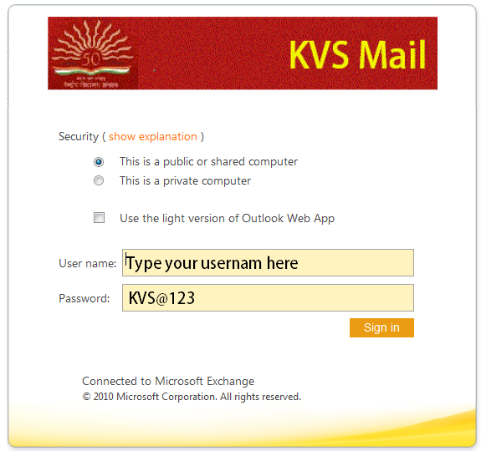

- The next screen will prompt you to change the password. Type your username and default password which is kvs@123 in the first two boxes.

- Type new password in the New Password box and again in the confirm new password box. (Please note that include number, capital letters, small letters and symbols in your password.)

- Click submit to complete the process
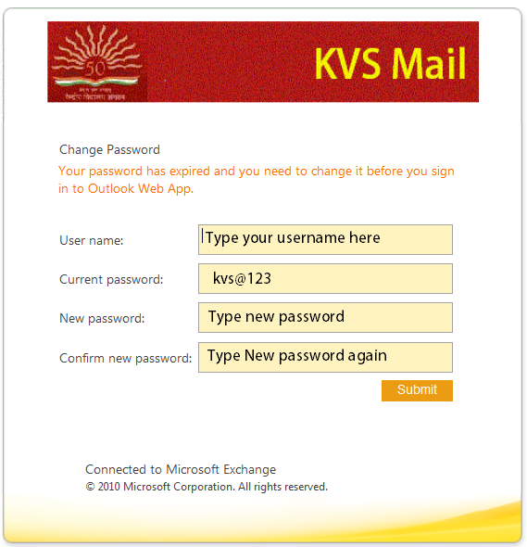

- The next scree will show successful password change

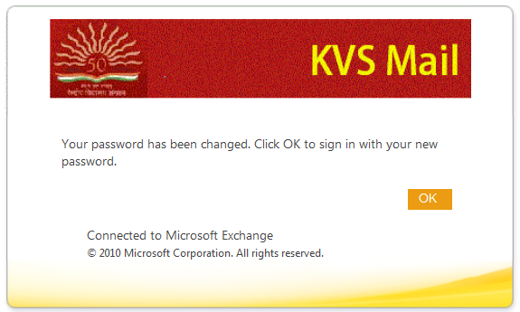
- Open any browser viz. Internet explorer, Chrome, Netscape and open URL
https://mail.kvsedu.org
- Type your username in the next screen. If you email ID is XYZ@kvsedu.org then you username will be XYZ.

- Type the new password in the password field and click Sign In
- Successful authentication will open your official mailbox.
